Club Details
JU Makerspace
logo-
Brief Summary
JU Makerspace is a collaborative workspace at JECRC University, Jaipur, aimed at fostering projects at the intersection of technology, creativity, and innovation. It was founded in 2016 by Mohit Johar, a student of JECRC University, who pioneered the initiative. Operating as the official Innovation Cell of JECRC University, it has grown to a community of over 1,600 followers on Instagram. The space encourages everyone — regardless of expertise — to ideate, experiment, prototype, and build, combining the DIY spirit with hands-on education. Members engage in a wide range of disciplines including coding, 3D printing, electronics, Arduino, soldering, woodworking, and more. The club has also forged strategic partnerships with organizations such as TCS, STI Hub, Tech Mahindra, and Wipro, opening doors for collaborative research and industry-level internships.
Projects/Inintiatives
1. Save The Saviours — COVID Face Shield Drive

During the COVID-19 pandemic, JU Makerspace launched the #Save_The_Saviours initiative, committing to producing 5,000+ face shields for hospitals in Delhi NCR to support frontline Covid warriors. The initiative was praised on social media by the then Chief Minister of Rajasthan, Shri Ashok Gehlot, bringing significant recognition to the club. Alongside this, members also developed a social distance badge and a face mask detector in April 2021 to address public health challenges during the pandemic. This initiative reflected the club's commitment to using technology for meaningful social impact. It stands as one of JU Makerspace's most celebrated real-world contributions to date.
2. Smart India Hackathon (SIH) & EYECAN — IEEE YESIST12
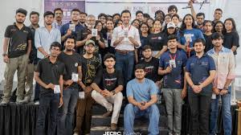
JU Makerspace received funding of ₹1 Lakh from the Smart India Hackathon (SIH), a Government of India initiative, recognizing the quality and impact of their work. The team also participated in the IEEE YESIST12 Innovation Challenge with their project "EYECAN," successfully clearing all three rounds and reaching the finals held in Tunisia. Competing on a global stage, the team demonstrated their ability to build solutions for real-world problems. Additionally, JU Makerspace was runners-up in the ideathon organized by Wipro, competing against top teams from across the country. These achievements highlight the club's growing presence in national and international innovation circles.
3. Summer With Makerspace (SW-MKS) — Free Tech Workshops 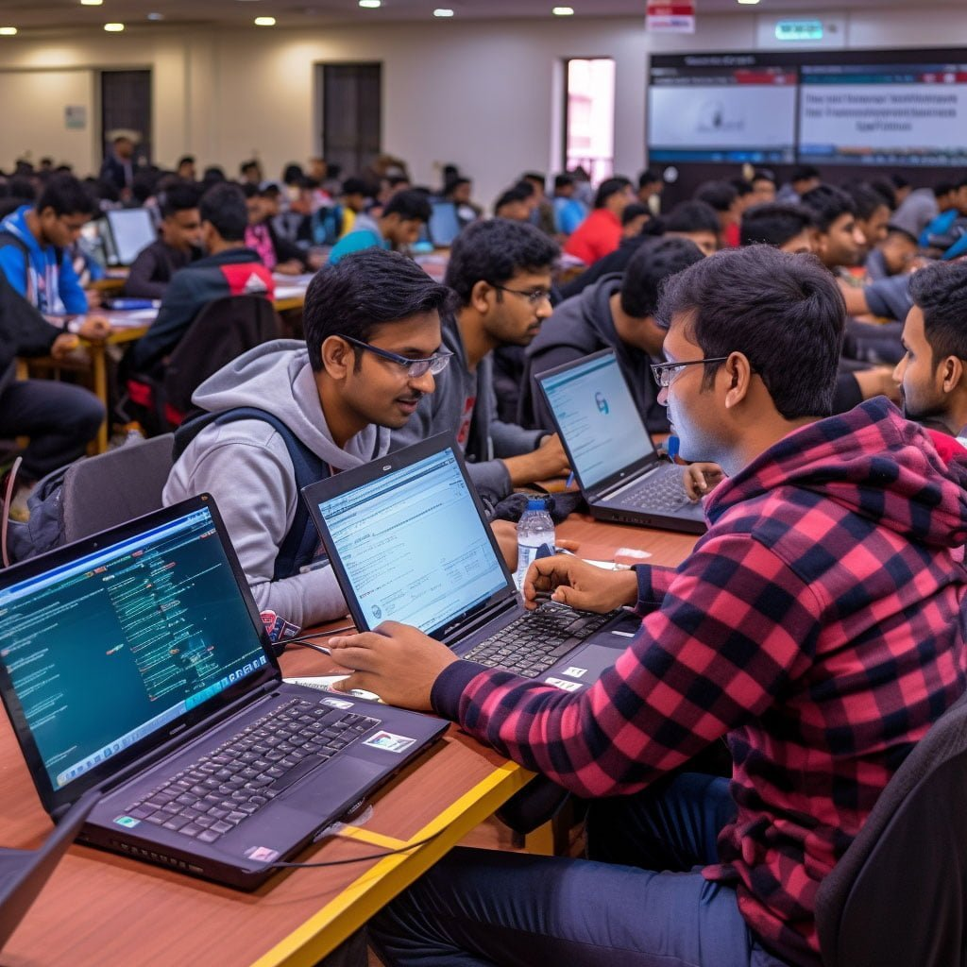
SW-MKS (Summer with Makerspace) is a free workshop series provided by JU Makerspace members, designed to motivate students to explore trending technologies in a fun and interactive way. The sessions cover topics like Python, Machine Learning, Arduino, Web Development, and Control Algorithms for Drones. During the lockdown period, the club shifted these workshops online, ensuring learning continued uninterrupted. The programme is structured to be inclusive, welcoming students of all backgrounds regardless of prior technical knowledge. It serves as a key pipeline for nurturing new talent and building the next generation of makers within the university.

JU AASHAYEIN
Logo-
Aashayein is a student-led community at JECRC University driven by service, compassion, and social responsibility, acting as a bridge between helpers and those in need. It is one of four social clubs at JECRC, alongside Soch, Zarurat, and Suhasini, all dedicated to promoting social awareness and positive change. The club is guided by Mr. Bhatt Vaibhav as core head, with Prof. Jagdev Singh serving as teacher coordinator since its very first day. Over the years, Aashayein has facilitated over 23,000 blood donations and 3,000+ Single Donor Platelets (SDP), saving countless lives. The community maintains a database of 1,437 active donors, with donations continuing to grow each day. The club firmly believes that small actions, when united, create powerful change — living up to its identity as the Life Saviours of JECRC University.
Projects/Initiatives
1. Blood Donation Camps
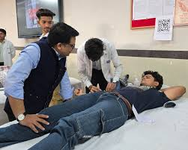
Aashayein organizes year-round Blood Donation Camps as its flagship initiative, accumulating a remarkable legacy of over 23,000 blood donations and 3,000+ Single Donor Platelets over the years. In one year alone, 3,132 donations were recorded through these camps, reflecting the club's remarkable consistency and mobilizing capacity. The camps are complemented by emergency response drives to address urgent blood requirements in hospitals across the region. The club's active donor database of 1,437 members ensures that emergency needs can be met swiftly and reliably. This initiative stands as the most impactful and defining contribution of JU Aashayein, making it one of the most active blood donation networks among college clubs in Jaipur.
2. Hospital & Old Age Home Visits
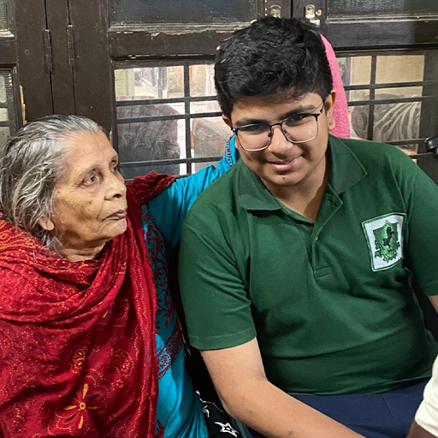
Aashayein regularly organizes visits to hospitals and old age homes as part of its mission to spread empathy, warmth, and a sense of community to those who are often overlooked. These visits are designed not only to provide emotional support but also to cultivate a spirit of service and human connection among student volunteers. The club pairs these visits with health seminars that spread awareness on wellness and first aid to both the participants and the communities they serve. Students engage directly with patients and elderly residents, making the experience deeply formative for young volunteers. This initiative reflects Aashayein's core belief that healthcare is as much about compassion as it is about medicine.

3. Blood Group Check-up Drives
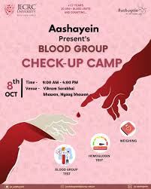

Alongside its donation camps, Aashayein has been running blood group check-up drives, with over 2,877 people benefiting from this service in a single year alone. These drives are typically held on campus and in surrounding communities, making essential health information accessible to students and residents who may otherwise lack access to basic diagnostics. The initiative helps build a verified, updated donor database that becomes invaluable during blood emergencies. Aashayein also conducts induction drives and health seminars alongside these camps to spread awareness on broader health and wellness topics. Together, these check-up drives and awareness programmes make Aashayein a comprehensive healthcare outreach club, not just a blood donation network.

JIC — JECRC Incubation Centre
Logo-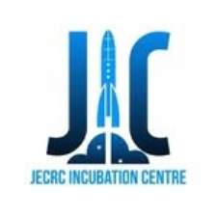
Brief summary -
JIC (JECRC Incubation Centre) was established at JECRC Foundation, Jaipur, born out of the institution's academic excellence and experience in research and innovation, with a vision to guide both campus students and entrepreneurs from across Rajasthan in turning their ideas into successful startups. It has become a one-of-its-kind startup incubation centre for young and ambitious founders who are addressing real-world challenges through their businesses, having built a collaborative entrepreneurial ecosystem and proven frameworks for early-stage startups to thrive and accelerate. With 150+ alumni-startups already supported and 50+ incubated startups under its belt, JIC's programs are designed to provide startups with the best resources and integrated support so they can evolve faster and better. Operating under the motto "Start Se Startup Tak," JIC intends to inspire individuals to innovate, offering mentoring, capital access, and structured incubation pathways to student entrepreneurs
Projects/initiative
Initiative 1 — KHOJ: The Startup Conclave
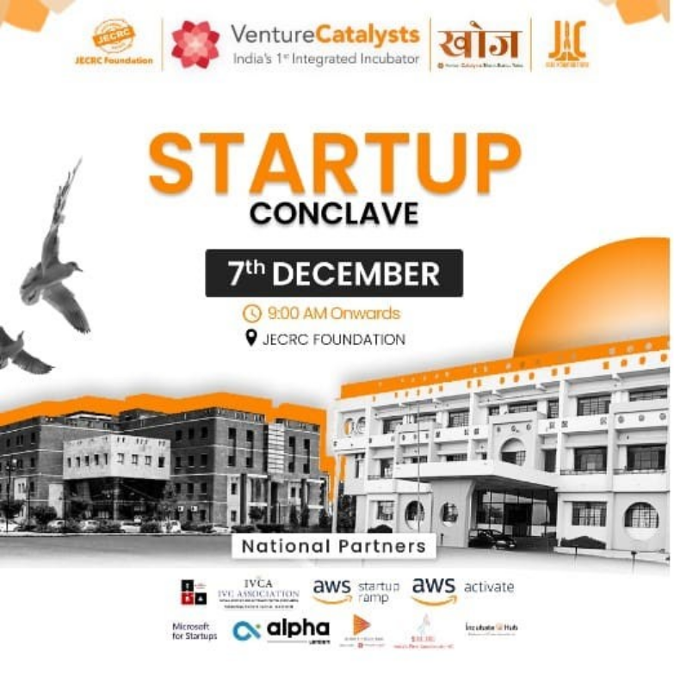
KHOJ – Bharat Startup Yatra was organized by JECRC Incubation Centre in association with Venture Catalysts, witnessing the presence of startups, investors, ecosystem enablers, and amazing founders from Jaipur's entrepreneurial ecosystem. The conclave brought together 40+ startups from 10+ colleges, featured 20+ prominent personalities, and offered cash prizes and credits worth over 2 lakh rupees and 2,700,000 USD in partner credits. National partners including IVCA, AWS Startup Ramp, AWS Activate, Alpha Microsoft for Startups, Beams Fintech Fund, and IncubateHub came under one roof, making it a landmark event for the Rajasthan startup ecosystem. The conclave featured pitching sessions, expos, quizzes, brand battles, and investor networking, providing early-stage founders with rare visibility and funding opportunities. It stands as one of JIC's most impactful events, connecting student innovators with real investors and industry leaders at scale.

Initiative 2 — Leader's Talk Series
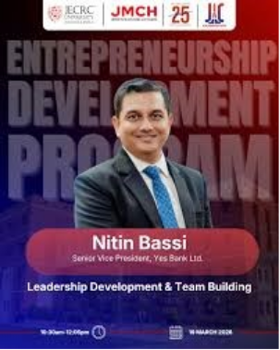
Leader's Talk is a talk series with pioneers of startups and organization leaders, designed to encourage young minds and motivate them to unleash their leadership potential. Past speakers have included Mugdha Sinha (Former IAS and present secretary at DST), Chintan Vaishnav (Director of Atal Innovation Mission), Harshit Mathur (Founder of Razorpay), Amit Jain (Founder of CarsDekho), and Chandresh Chand (Director of Engineering at Groww). The series exposes students to diverse paths in entrepreneurship and corporate leadership through first-hand accounts from some of India's most recognized names. By bridging the gap between student ambition and real-world execution, Leader's Talk serves as a consistent source of inspiration on campus. It reinforces JIC's broader mission of nurturing not just startups, but entrepreneurial mindsets from the ground up.

Initiative 3 — Accelerator & Incubation Program
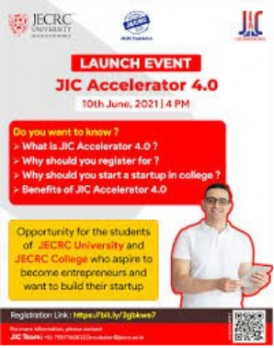
JIC's Accelerator Program is an intensive 10-week initiative for JECRC students that helps them take their ideas to market through workshops and mentoring sessions, with selected startups also receiving seed funding support. The Incubation Program complements this by connecting to the Accelerator Program, giving students foundational knowledge about startups, pitch decks, and pitching, while ensuring they progress from ideation to building an MVP. JECRC Foundation is noted as the first institute in Rajasthan to have a well-defined startup policy for students who want to pursue startups, with provisions including seed funds, access to mentor and investor networks, and special scholarships for women entrepreneurs. The program has already produced multiple incubated ventures across sectors like AgriTech, EduTech, and Mobile Apps. Together, these programs form a complete pipeline that takes a student from raw idea to a fundable, market-ready startup.

Abhivyakti Club
Logo-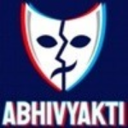

Brief Summary
Abhivyakti Club — The Drama Society of JECRC University
Abhivyakti Club is the dramatic and acting club of JECRC University, Jaipur. The club initiates to help students explore the dramatic artists within themselves during their college lives, with its main motive being to help members express themselves through emotions and enact stories with the help of them. Talking about the vision, the club is not only focused on developing dramatic artistic skills in students, but also the holistic and overall development of their personality. JECRC University's campus hosts student clubs like Maverick Club, Abhivyakti Club, and the Literature Club so that students can socialise with each other and explore interests as extracurricular activities. It serves as a creative outlet where students from all branches can come together, collaborate, and present their artistic work to the wider university community. The club actively participates in the university's annual techno-cultural fest, JU Rhythm, and various inter-college competitions, making it a key pillar of campus cultural life.
Projects / Initiatives
Initiative 1 — JU Rhythm — Annual Techno-Cultural Fest Performances
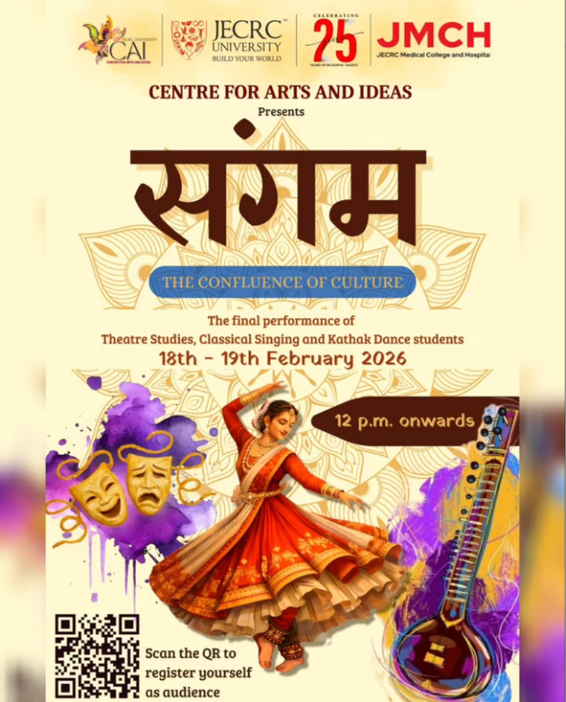
JU Rhythm is JECRC University's flagship techno-business-cultural festival, bringing together talent, creativity, and innovation on a grand stage, attracting 25,000+ attendees and offering 50+ electrifying events across technology, business, music, arts, and sports. The cultural extravaganza features a blend of dance, music, fashion shows, and theatrical performances. Abhivyakti Club is one of the key contributors to the theatrical dimension of this fest, staging dramatic productions that serve as some of the most anticipated performances of the event. JU Rhythm is envisioned as a best techno-cultural fest to bring out and explore talent in budding students, with dramatics being one of the major spotlights alongside dance and literature. The fest gives Abhivyakti members a grand platform to showcase their acting, scriptwriting, and stage craft skills to a massive audience each year.

Initiative 2 — Drama Workshops & Acting Skill Development
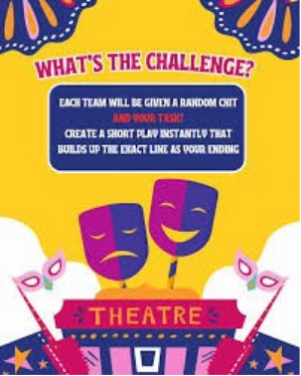

As part of its core mission, Abhivyakti Club regularly organizes acting workshops, script-reading sessions, and rehearsal-based skill-building activities for its members throughout the academic year. The club's vision goes beyond dramatic artistic skills to focus on the holistic and overall development of the personality of students. These workshops invite experienced theatre practitioners, alumni, and faculty mentors to guide students in areas like stage presence, voice modulation, improvisation, and emotional expression. The university has hosted personalities like Chandan Kumar Jangid, a theater artist and JECRC University alumnus, alongside acclaimed Hindi novelists and established poets, who shared the pearls of wisdom with students. This rich ecosystem of guidance directly benefits Abhivyakti members and helps them build confidence well beyond the stage.

Initiative 3 — Inter-College Competitions & Social Awareness Performances
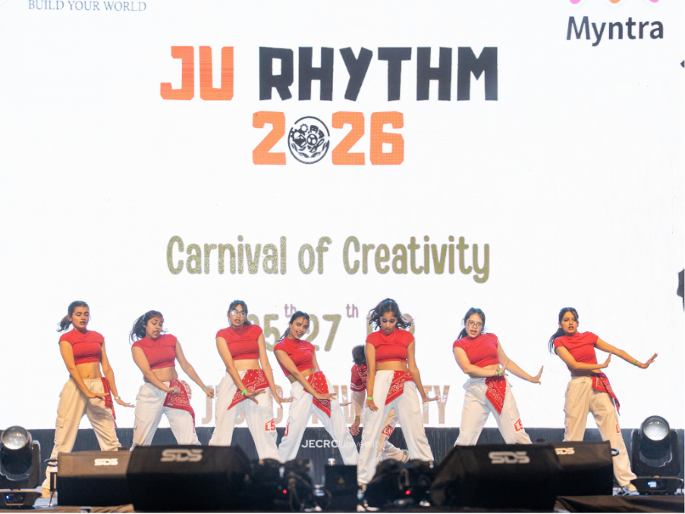
Abhivyakti Club regularly represents JECRC University at inter-college drama and street play competitions, taking the club's creative energy to wider platforms. JECRC University is known for its vibrant club culture where students explore interests as extracurricular activities and compete at inter-university levels. The club also uses the powerful medium of theatre for social messaging — performing nukkad nataks (street plays) that highlight pressing social issues such as gender equality, environmental awareness, and mental health, directly engaging audiences on campus and beyond. The club's main motive is to help students express themselves through emotions and enact stories, and this philosophy naturally lends itself to using drama as a tool for social change. Such performances add a meaningful dimension to the club's identity, positioning it as both a creative and socially conscious platform.

SWARAAG Club


SWARAAG is the official music club of JECRC University that promotes singing and instrumental talent on campus.
The club provides students opportunities to perform during university events and cultural fests.
Past Events & Initiatives:
- Live Jamming Sessions
- Musical Nights during JU Rhythm
- Singing Competitions
- Open Stage Performances
- Acoustic Evenings
Maverick Club

Maverick Club is the official media and photography club of JECRC University.
The club handles photography, videography, editing, and event media coverage.
Past Events & Initiatives:
- JU Rhythm Coverage
- Photography Competitions
- Photowalks
- Editing Workshops
- Sports & Fest Media Coverage

JU-Socialz


JU-Socialz is the social media marketing and branding cell representing JECRC University online.
The club manages promotions, digital campaigns, and university branding activities.
Past Events & Initiatives:
- Social Media Campaigns
- Event Promotions
- Digital Branding Activities
- Student Engagement Campaigns
- Fest Media Management
Gladiators



Gladiators is the premier eSports and gaming club of JECRC University.
The community promotes competitive gaming and gaming culture among students.

Past Events & Initiatives:
- BGMI Tournaments
- Valorant Championships
- FIFA Competitions
- Gaming Nights
- Inter-college eSports Events

JU Eagles

JU Eagles is the official sports club of JECRC University representing the university in sports activities.
The club encourages fitness, teamwork, and athletic participation.
Past Events & Initiatives:
- JU Premier League
- Inter-college Sports Tournaments
- Cricket & Football Competitions
- Fitness Activities
- Sports Training Sessions

Renegade

Renegade is a student rap and hip-hop community for students passionate about rap culture and music.
The club supports lyrical creativity, freestyle sessions, and underground performances.
Past Events & Initiatives:
- Rap Battles
- Cypher Sessions
- Open Mic Performances
- Hip-Hop Showcases
- Music Collaboration Sessions

